CHEMICAL ENGINEERING TRANSACTIONS  VOL. , 2023 | A publication of
The Italian Association
of Chemical Engineering
Online at www.cetjournal.it

Guest Editors: David Bogle, Flavio Manenti, Piero Salatino
Copyright © 2023, AIDIC Servizi S.r.l.
ISBN 979-12-81206-04-5; ISSN 2283-9216

Definition of an Experimental Set-up for Studying the Safety of Hydrogen Transport Systems
Elpida Piperopoulos^{a,*}, Maria Francesca Milazzoª, Sina Rahimiª, Paolo Bruzzanitiª, Edoardo Proverbioª
ªDipartimento di Ingegneria, Università di Messina, Contrada di Dio, 98166 Messina, Italy
elpida.piperopoulos@unime.it
The required energy transition, unavoidable for the decarbonisation of industrial processes and economic sectors, is increasing the attention in Europe and around the world towards hydrogen. Hydrogen is an energy carrier, globally trusted to meet climate challenges, as it can store and deliver large amounts of energy per unit mass, reducing CO₂ emissions. Hydrogen can be used as a feedstock, a fuel or an energy carrier and storage and it has many possible applications in the industrial, transport, energy and construction sectors. These properties make hydrogen essential to support the EU's commitment to achieve carbon neutrality by 2050 and for the global effort to implement the Paris Agreement while working towards zero pollution. For the purpose of facilitate this process, it is necessary to have a network capable of making this resource usable in a capillary, efficient and safe way. Gas pipelines, used to transport natural gas, can be exploited for the transport of pure or mixed hydrogen. It is therefore necessary to understand how hydrogen can affect the integrity and safety of gas pipelines, in order to establish whether the hydrogen/natural gas mixture is a viable and safe solution and within what ratios. Hydrogen embrittlement manifests in a loss of mechanical properties such as decreased ductility and toughness, increasing failure likelihood and gas releases, which are very dangerous, due to hydrogen ability to catch fire very easily and to the explosion hazard. The purpose of this work is the design and demonstration of a test setup for pipeline steel in a high-pressure gaseous hydrogen environment, by means of miniature hollow pipe-like specimen working at high-pressure hydrogen, in a safe and easily accessible manner with the basic laboratory equipment.
  - Introduction
The energy transition is a crucial step towards decarbonizing industrial processes (IEA, 2020; IEA, 2021). Industries account for a significant portion of global greenhouse gas emissions, which contribute to climate change. The decarbonization of industrial processes is necessary to mitigate the harmful effects of climate change and achieve global sustainability goals (Hansen et al., 2013; Jacobson et al., 2018). The energy transition involves shifting away from traditional fossil fuels and towards cleaner and renewable sources of energy, such as solar, wind, hydropower and hydrogen (Kalair et al., 2020). By doing so, industries can significantly reduce their carbon footprint and achieve carbon neutrality, which is essential for the long-term sustainability of the planet. By embracing renewable energy sources and reducing their carbon footprint, industries can mitigate the effects of climate change and achieve long-term sustainability goals while also reaping other economic benefits. The use of hydrogen as a feedstock can support the transition towards a low-carbon economy by enabling the production of cleaner fuels and chemicals, reducing greenhouse gas emissions, and promoting the use of renewable energy sources (Nicita et al., 2020; Shamsi et al., 2023). Hydrogen is considered a promising alternative to fossil fuels (Zuttel et al., 2010) but the widespread use of hydrogen as an energy supply is currently limited by different reasons, including the lack of infrastructure for its distribution and use (Mazloomi and Gomes, 2012). Natural gas transportation pipelines have the potential to be used for transporting hydrogen in its pure form or when mixed with other gases. To determine the feasibility and safety of using a hydrogen/natural gas blend, it is crucial to comprehend the impact of hydrogen on the safety and durability of the pipelines and identify the appropriate mixing ratios.
Hydrogen Embrittlement (HE) is a phenomenon that has been extensively studied in materials science and engineering, particularly in the context of steel. When steel is exposed to hydrogen, its mechanical properties can be severely compromised, leading to unexpected failures and catastrophic consequences. Hydrogen embrittlement occurs when atoms diffuse into metals and can cause them to become brittle and fracture. The embrittlement process typically involves three key stages: hydrogen absorption, hydrogen diffusion, and hydrogen-induced cracking. During hydrogen absorption, atomic hydrogen from the environment can penetrate the steel's surface. Once hydrogen is absorbed into the steel, it can diffuse through the metal lattice, moving towards areas of stress concentration. The hydrogen atoms can accumulate at grain boundaries, dislocations, and other microstructural defects within the steel. As the concentration of hydrogen increases in these regions, it can weaken the atomic bonds and reduce the material's ductility and toughness. The final stage of hydrogen embrittlement is the formation of cracks. The accumulated hydrogen atoms can create local regions of high stress within the steel. This can lead to the formation and propagation of cracks, even under relatively low applied stress. These cracks can be both intergranular (along the grain boundaries) and transgranular (through the grains). Several factors can influence the susceptibility of steel to hydrogen embrittlement. These include the steel's composition, microstructure, hardness, and the severity and duration of exposure to hydrogen. Additionally, external factors like temperature, stress levels, and the presence of corrosive substances can also contribute to the embrittlement process (Jia et al., 2023).
High-strength carbon steels, for example, are particularly prone to embrittlement due to high hydrogen solubility (Nelson, 1983; Sofronis and Robertson, 2012; Kappes, 2008). Different instances of HE have been reported, and numerous theories have been postulated to explain this phenomenon. Many experiments have been carried out to reproduce and consequently better understand the HE mechanism on steels.
Some researchers (Boot et al., 2021) conducted a study in which they developed and tested an in-situ experimental setup designed to evaluate X60 pipeline steels in a high-pressure gaseous hydrogen atmosphere.
In order to establish the crucial safety ratio for mixing hydrogen, experiments were conducted by Wang et al. (2023) on X80 pipeline steel using high-pressure hydrogen permeation tests and slow strain rate tensile tests. These experiments were carried out in environments that simulate natural gas mixed with hydrogen at varying volumes of 0% to 20%.
The purpose of this research paper is to create and exhibit a testing arrangement that can be used to evaluate steel pipelines in high-pressure gaseous hydrogen surroundings, meaning within the probable environment where the material will be used or exposed. This is different from conventional laboratory setups and provides a more realistic representation of the effects on the structural integrity and properties of steel. This arrangement involves conducting tensile tests on a miniature hollow pipe-shaped sample that contains high-pressure hydrogen. The testing setup should be both safe and easily accessible and can be assembled using basic laboratory equipment. The article is structured as follows, Section 2 shows the materials and methods used for the research; Section 3 reports the realization of the testing setup; Section 4 gives the results and discussion; and, finally, Section 5 reports the conclusions.
  - Materials and Method
    - Steel specimen
The specimen 3D, 2D schemes and measurements are shown in Figure 1.
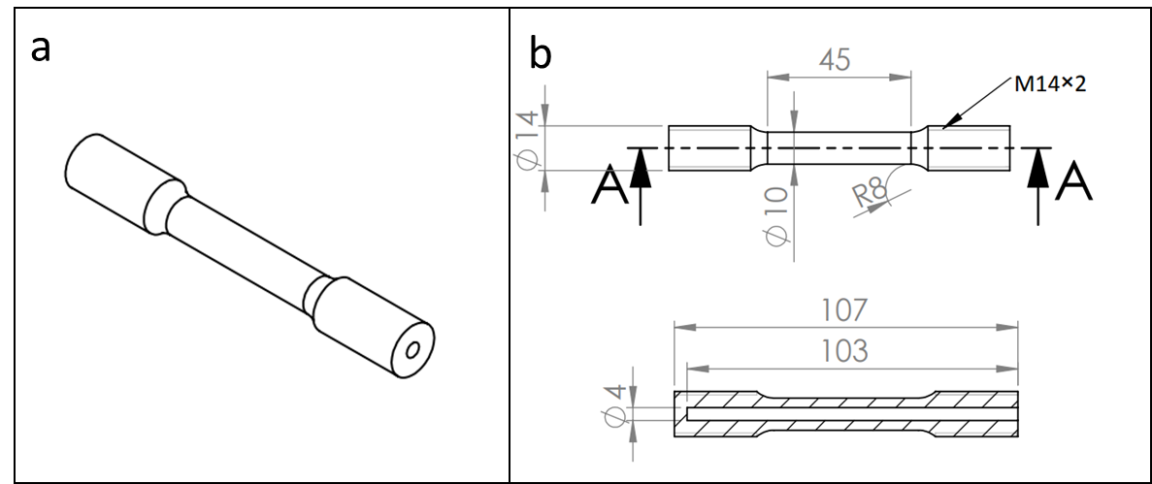
Figure 1: 3D (a) and 2D (b) schemes of the employed specimen. Measurements are in mm.
The material of the cylindrical specimen, used for the test, is an API 5L X65 steel. The specimen has a blind circular hole (Ø 3 mm), created by drilling. The hole was finished by reaming. Finally, the ends of the specimen are threaded to be connected to the tensile machine adapters.

    - Tensile test
Slow strain rate tensile tests to determine HE on previously described tubular samples were performed by means of a Universal Testing Machine (Zwick-Roell Z250) equipped with 250 kN load cell and a cross-head rate of 0.0024 mm/min (displacement control test). Three replicas were carried for each specimen. The tensile machine was associated with the TestXpert II software, installed on a computer, for user interface on the control commands and test results. To evaluate the effect of hydrogen on the material, two types of investigations were conducted. The first on empty samples (E-S), the second on hydrogen gas pressurized samples (HP-S). When a hydrogen test was performed, a pre-charge procedure was included in the test. The system was purged twice with nitrogen gas and evacuated, by means of a vacuum pump, to remove any impurities. It was, then, pressurized to the test pressure (100 bar) with hydrogen, monitored for 10 minutes to ensure that no leaks were present and then maintained 24 hours to allow the gas to diffuse into the steel. After that, the slow strain rate test started.
The fractured surfaces of specimens were analyzed by 3D optical microscope (model KH8700 3D digital microscope by Hirox, Japan).
  - In-situ test setup Design
To connect the specimen to the tensile machine two adapters were realized, the bottom one is represented in Figure 2.
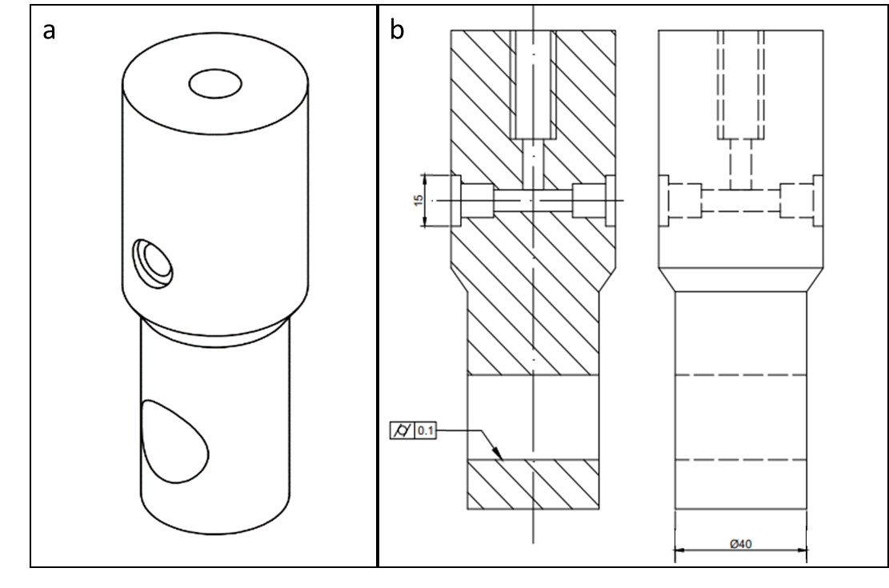
Figure 2: 3D (a) and 2D (b) schemes of the realized adapter. Measurements are in mm.

An overview of the testing setup is presented in Figure 3a, while its 2D diagram is displayed in Figure 3b. The specimen is connected to the adapters using threaded holes, and the bottom adapter is responsible for linking the specimen to the tubing that supplies and removes gas from inside it. One end of the tubing is connected to N₂ and H₂ bottles as well as a pressure gauge, which are utilized to pressurize the system for testing purposes. The other end of the tubing is linked to a release valve, which can be employed to stop the test before completion, and a vacuum pump, which eliminates gases from the system. To restrict the amount of gas released when the specimen fractures, a portion of the entire system, including the specimen, can be sealed off to create a consistent volume of around 6 ml. This volume conforms to the regulations specified by the EU's Pressure Equipment Directive for pressures up to 200 bar, which means that the setup can be utilized without requiring specialized facilities.

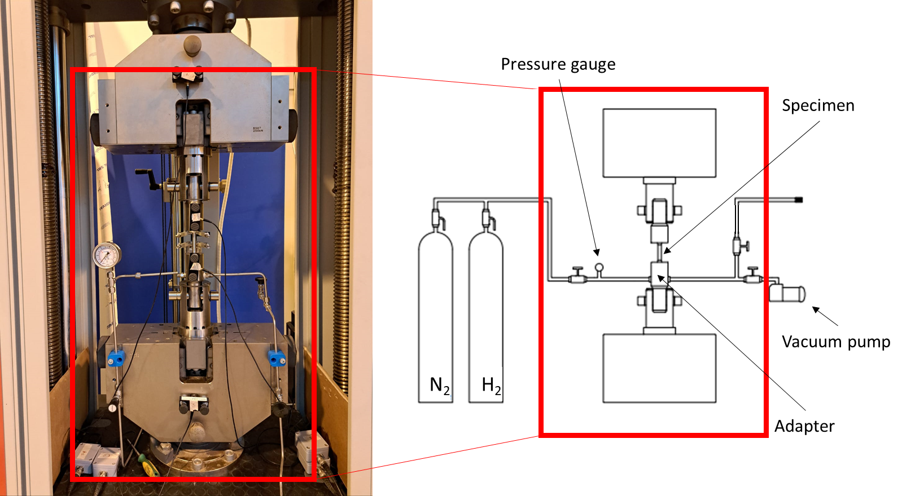
Figure 3: 3D (a) and 2D (b) schemes of the testing setup. Measurements are in mm
  - Results
A significant loss of ultimate tensile strain (in %) is shown for steel sample tested in 100 bar H₂ when compared to the empty one, as it can be seen in Figure 4.

Figure 4: Strain tensile test results from ES (red dotted curve) and HP-S (blue solid curve) samples.
The HP-S sample shows a reduction in % strain of 9.47 %. For HP-S, the behaviour of the tensile curve is almost unchanged up to 7 % of strain, the value after which the Engineering Stress decreases until the fracture is quickly reached. The role of plastic deformation on hydrogen embrittlement (HE) is highlighted, as it leads to a higher density of dislocations and voids that result in increased hydrogen solubility (Lufrano and Sofronis, 1998) (Nagumo, 2004) (McLellan and Xu, 1997).
As reported in Table 1, a small decrease in ultimate tensile strength is evidenced for HP-S sample in comparison with the E-S one, 552,88±4,2 MPa and 560,55±3,1 MPa respectively, coupled with a significant reduction in percent elongation in the presence of pressurized hydrogen as a consequence of the embrittlement effect of hydrogen diffusion in the steel.
Table 1: Table Stress and strain. Standard deviations are also reported.
Sample | σ_{max}  [MPa] | ε at σ_{max}  [%] | σ_{failure}  [MPa] | ε at σ_{failure}  [%]
E-S | 560,55±3,1 | 8,54±0,1 | 201,83±26,2 | 20,43±0,7
HP-S | 552,88±4,2 | 7,28±0.8 | 203,42±28.8 | 10,96±1.1

After conducting the tests, the fracture surfaces of the specimens were examined (as shown in Figure 5). The fracture surface of the specimen tested in hydrogen (Figure 5b) appears noticeably different from that one of the E-S specimen. The specimen tested in air displays a cup-cone fracture pattern, which is typical of ductile fracture. However, a brittle-like fracture surface in the specimen tested in hydrogen with a significant reduction of striction is noticed. This means that the material is more prone to fracturing without undergoing significant deformation or necking. Figure 5c shows an optical micrograph of the crack propagation through the sample wall after being tested in hydrogen gas.
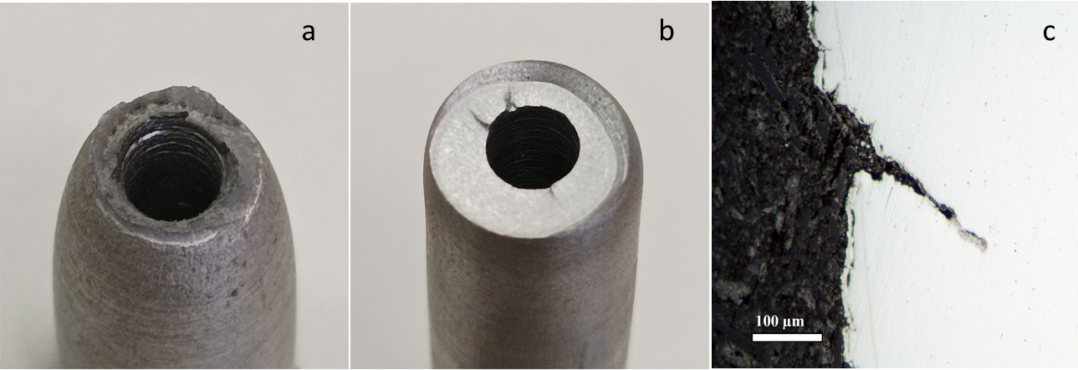
Figure 5: Images of fracture surface for E-S (a) and HP-S (b) samples. Optical micrograph of the crack propagation through the sample wall after testing in hydrogen gas

This research used a particular combination of specimen shape and testing method to study the HE on X65 carbon steel. The specific application to pipeline steels and the in-situ test setup differentiate this research and make it innovative. It offers insights into the behaviour and suitability of pipeline steels under difficult operating conditions, contributing to the understanding of materials for hydrogen-related infrastructure. Further investigations, using inert gas at 100 bar pressure and the effect of using mixtures of natural gas and hydrogen in different ratios will be investigated to better evaluate the safety level of hydrogen transport systems.
  - Conclusions
The main objective of this study was to design and assemble a tensile test apparatus that employed hollow steel specimens filled with pressurized gas, which was subsequently used to analyse the hydrogen embrittlement (HE) behaviour of API 5L X65 carbon steel. The research yielded several key findings:
- By subjecting steel specimens to a continuous hydrogen gas pressure for a prolonged period, the testing arrangement can effectively promote hydrogen diffusion into the steel. This enables safe laboratory testing of steel specimens until they fail, with the release of just 6 ml of pressurized gas upon fracture.
- A decrease in ultimate tensile strength was evidenced for HP-S sample in comparison with the E-S one, 552,88±4,2 MPa and 560,55±3,1 MPa respectively, coupled with a significant reduction in percent elongation (1.26 %) in the presence of pressurized gas.
- Fractographic analysis revealed that API 5L X65 pipeline steel is vulnerable to hydrogen embrittlement (HE) when subjected to a hydrogen pressure of 100 bar. This was corroborated by the brittle-like fracture surface of the specimen and the presence of cracks propagating through the sample during the tensile test.
The results of the study will allow the acquisition of useful information for determining the probability of failure for the pipeline in order to support, through a risk assessment, the choice of the conditions of use of the pipelines (in term of operating conditions and gaseous components ratio).
Acknowledgments
This work has been funded by INAIL within the BRIC/2021 ID = 3 project DRIVERS.
References
Boot T., Riemslag T. A. C., Reiton E. T. E., Liu P., Walters C. L., Popovich V., 2021, In-Situ Hollow Sample Setup Design for Mechanical Characterisation of Gaseous Hydrogen Embrittlement of Pipeline Steels and Welds, Metals, 11, 1242-1257.
Energy Technology Perspectives 2020: Special Report on Clean Energy Innovation. Paris: IEA, 2020, International Energy Agency <https://www.iea.org/reports/energy-technology-perspectives-2020> accessed 29.03.2023.
Hansen J., Kharecha P., Sato M., Masson-Delmotte V., Ackerman F., Beerling D. J., Zachos J. C., 2013, Assessing “dangerous climate change”: Required reduction of carbon emissions to protect young people, future generations and nature, PLoS One, 8, e81648-e81673.
Jacobson M. Z., Delucchi M. A., Bauer Z. A. F., Goodman S. C., Chapman W. E., Cameron M. A., Bozonnat C., Chobadi L., Clonts H. A., Enevoldsen P., Erwin J. R., Fobi S.N., Goldstrom O. K., Hennessy E. M., Liu J., Lo J., Meyer C.B:, Morris S. B., Moy, K. R., O’Neill P. L., Petkov I., Redfern S., Schucker R., Sontag M. A., Wang J., Weiner E., Yachanin A.S., 2017, 100% clean and renewable wind, water, and sunlight (WWS) all-sector energy roadmaps for 139 countries of the world, Joule, 1, 108-121.
Jia G., Lei M., Li M., Xu W., Li R., Lu Y., Cai M., 2023, Hydrogen embrittlement in hydrogen-blended natural gas transportation systems: A review, International Journal of Hydrogen Energy, in press.
Kalair A., Abas N., Saleem M.S., Kalair A.R, Khan N., 2020, Role of energy storage systems in energy transition from fossil fuels to renewables, Energy Storage, 3, e135-e156.
Kappes M. A., 2008, Hydrogen Embrittlement, ASM Handbook Volume 13B: Corrosion: Materials, ASM International, 940-948.
Lufrano J., Sofronis P., 1998, Enhanced hydrogen concentrations ahead of rounded notches and cracks—Competition between plastic strain and hydrostatic stress, Acta Materialia, 46, 1519–1526.
Mazloomi K., Gomes C., 2012, Hydrogen as an energy carrier: Prospects and challenges, Renewable and Sustainable Energy Reviews, 16, 3024-3033.
McLellan R.B., Xu Z.R., Hydrogen-induced vacancies in the iron lattice. Scripta Materialia, 36, 1201-1205.
Nagumo M., 2004, Hydrogen related failure of steels—A new aspect, Mater. Sci. Technol., 20, 940–950
Nelson H. G., 1983, Hydrogen Embrittlement, Treatise on Materials Science & Technology, 25, 275-359.
Net Zero by 2050: A Roadmap for the Global Energy Sector. Paris: IEA, 2021, International Energy Agency < https://www.iea.org/reports/net-zero-by-2050> accessed 29.03.2023.
Nicita A., Maggio G., Andaloro A.P.F., Squadrito G., 2020, Green hydrogen as feedstock: Financial analysis of a photovoltaic-powered electrolysis plant, International Journal of Hydrogen Energy, 45, 11395-11408.
Shamsi M., Moghaddas S., Naeiji E., Farokhi S., 2023, Techno-Economic, Energy, Exergy, and Environmental Comparison of Hydrogen Production from Natural gas, Biogas, and their Combination as Feedstock, Arabian Journal for Science and Engineering, in press
Sofronis P., Robertson I. M., 2012, Hydrogen Embrittlement, Comprehensive Structural Integrity, 6, Elsevier, 291-322.
Wang C., Zhang J., Liu C., Hu Q., Zhang R., Xu X., Yang H., Ning Y., Li Y., 2023, Study on hydrogen embrittlement susceptibility of X80 steel through in-situ gaseous hydrogen permeation and slow strain rate tensile tests, International Journal of Hydrogen Energy, 48, 243-256.
Zuttel A., Remhof A., Borgschulte A., Friedrichs O., 2010, Hydrogen: the future energy carrier, Philos Trans A Math Phys Eng Sci, 368, 3329-3342.

